**Introductory terms and Concepts:**

**Binaries:** executables in Linux like .exe files in windows.

**Case sensitivity**: Linux is case sensitive unlike windows.

**Directory**: like folders in windows.

**Home**: each user has their own /home directory where files created will be saved by default.

**Kali**: Kali Linux is a distribution of Linux specifically designed for penetration testing.

**Root**: like an administrator or superuser account having full control on the system.

**Script**: series of commands run in an interpretive environment.

**Shell**: this is an environment for running commands in Linux. E.g. bash(Bourne again shell).

**Terminal**: This is a command line interface(CLI).

**The Linux Filesystem:**

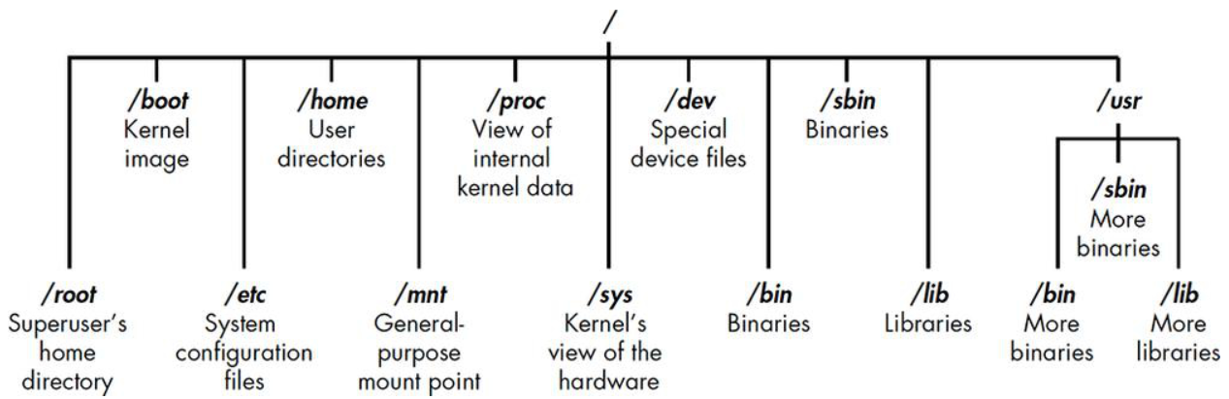

**/root:** home directory of root user.

**/etc:** contains the Linux configuration files – files that contains when and how programs start up.

**/home:** user’s own home directory.

**/mnt:** where other filesystems and mounted or attached to the filesystem.

**/media:** where CD or USB devices are mounted or attached to the filesystem.

**/bin:** where application binaries (like .exec files on windows) reside.

**/lib:** where we’ll find libraries (shared programs that are like window’s .dll files).

**Basic commands in Linux:**

**pwd**: present working directory.

**whoami**: which user you are logged in as.

**cd**: change directory.

**ls**: listing the contents of a directory.

**ls -l:** listing with more details about the contents of a directory.

**ls -al:** show all files details including the hidden files in a directory.

**--help**: to get help on using any command e.g. ls –help.

**Finding stuff:**

**locate**: to search for a keyword in entire filesystem and locate every occurrence of that word.

**whereis**: to locate where is the binary file residing and the man page if available.

**which**: finding binaries in the PATH variable.

**find:** *find directory options expression*

find / -type f -name apache2

find / -type f - -apache2.*

**WILDCARDS:**

* ? represents a single character.
* [] to search for characters that are present within this square bracket.
* * to match any character of any length.

**grep**: to search a keyword in the files or directories. Often used with | piping.

*ps aux | grep apache2*

**Modifying files and directories:**

**cat:** cat followed by a > sign and filename will create a new file and prompt will wait for you to type the content of the file. Ctrl + D to bring the prompt back and cat <filename> to view the contents of file.

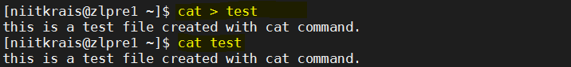

cat >> <filename> to append at the end of the file and cat > <filename> to overwrite the contents of the file.

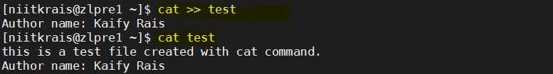

touch: to create a new empty file.

mkdir: to create a new directory.

cp: to copy file to a directory.

mv: to move or rename a file from one directory to another dir.

rm: to delete a file.

rmdir: to delete an empty directory. Use rmdir -r <dir_name> to delete directory and all its content.